Recon Techniques

Passive Subdomain Discovery using crt.sh
What it does:
Searches public SSL certificate logs to find subdomains without touching the target
command
curl -s "https://crt.sh/?q=%25.nmap.com&output=json" | jq -r '.[].name_value' | sort -u
Output
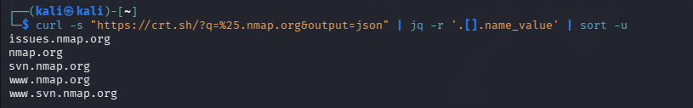
Findings
Target was nmap.org. The scan successfully discovered 4 subdomains including issues.nmap.org, svn.nmap.org, www.nmap.org, and www.svn.nmap.org, revealing the full subdomain structure of the target.

Historical URL Enumeration using Wayback Machine
What it does:
Retrieves all historically archived URLs of a target from public Wayback Machine records
Command:
curl"https://web.archive.org/cdx/search/cdx?url=*.testphp.vulnweb.com&output=json&fl=original&collapse=urlkey" | grep -v "favicon" | head -20

Output

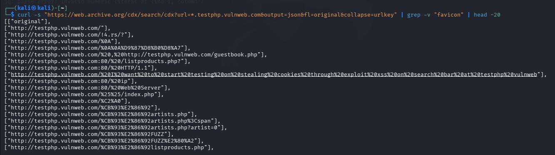

Findings
Target was testphp.vulnweb.com. The scan revealed multiple historical URLs including sensitive pages such as guestbook.php, listproducts.php, artists.php, and various encoded URLs suggesting the presence of search and testing functionality. Several URLs contained special characters and parameters indicating potential injection points for further testing.

Technology Fingerprinting using WhatWeb
What it does:
Identifies the technology stack of a website with a single passive request
Command:
whatweb nmap.org -a 1 --no-errors
Output

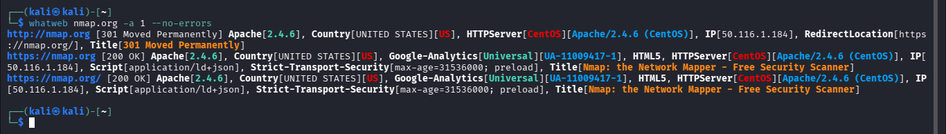
Findings
The scan revealed the server is running Apache 2.4.0 hosted in the United States with IP 50.116.1.184. Security headers were identified including Strict-Transport-Security, and the server is using Google Analytics. The response also exposed server technology details like CentOS operating system and RedirectLocation header, which could aid in fingerprinting the target infrastructure.

Email & Subdomain Harvesting using theHarvester
What it does: Automates OSINT gathering of emails, subdomains and IPs from public sources
Command:
theHarvester -d vulnweb.com -b crtsh,dnsdumpster
Output
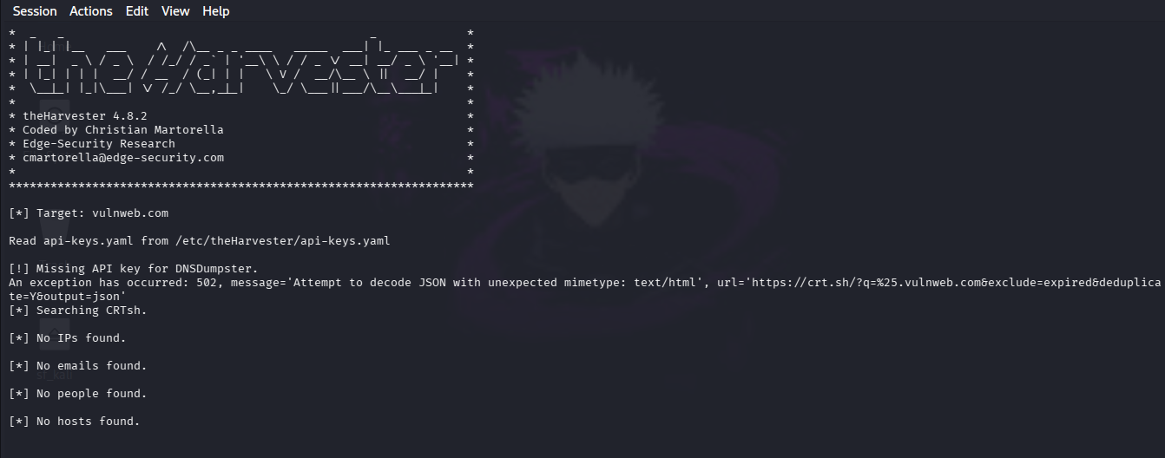

Finding
The tool queried multiple sources however no emails, hosts, or IPs were discovered. A minor error occurred while fetching SSL certificate data from crt.sh due to unexpected JSON mimetype. The scan confirms vulnweb.com has minimal public footprint with no exposed email addresses or additional hosts discoverable through passive reconnaissance.

Active Subdomain Brute Forcing using dnsx

What it does: Actively brute forces subdomains by testing thousands of common names against a target
Command:
cat /usr/share/seclists/Discovery/DNS/subdomains-top1million-5000.txt | awk '{print $1".vulnweb.com"}' | dnsx -resolver 8.8.8.8 -resp -o found-subs.txt
Output
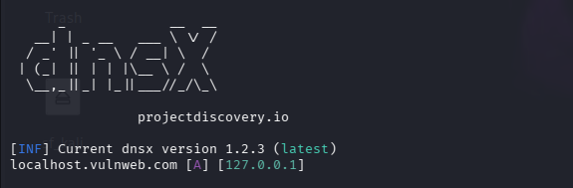
Findings
One live subdomain was discovered — localhost.vulnweb.com resolving to 127.0.0.1 (loopback address), indicating a misconfigured or test subdomain pointing back to the local machine rather than a public IP.

Fast Subdomain Brute Forcing using shuffledns
What it does:
Same as dnsx but uses hundreds of public DNS resolvers simultaneously for faster results
Command:
shuffledns -d vulnweb.com -w /usr/share/seclists/Discovery/DNS/subdomains-top1million-5000.txt -r resolvers.txt -o found.txt

Output
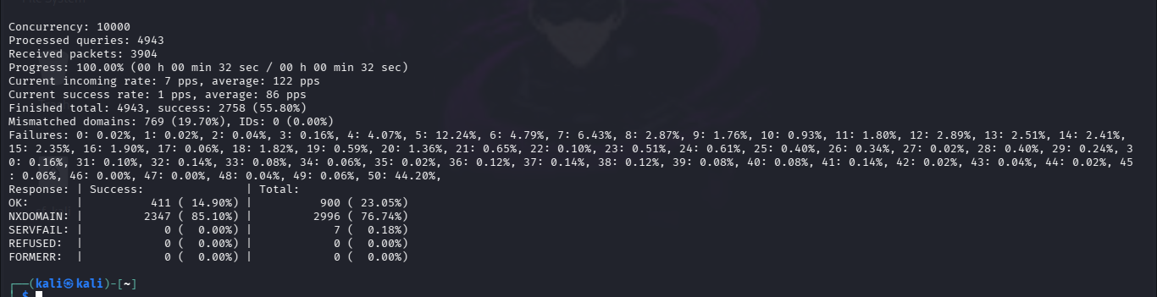
Findings
A total of 4943 queries were processed with 2758 successful responses. Out of all responses 411 returned valid OK status while 2347 returned NXDOMAIN indicating non-existent subdomains. No SERVFAIL or REFUSED responses were observed, confirming stable DNS resolution throughout the scan.

Web Directory Discovery using ffuf
What it does:
Tests thousands of possible directory names to find hidden pages on a website
Command:
ffuf -u http://testphp.vulnweb.com/FUZZ -w /usr/share/wordlists/dirb/small.txt -fc 404
Output
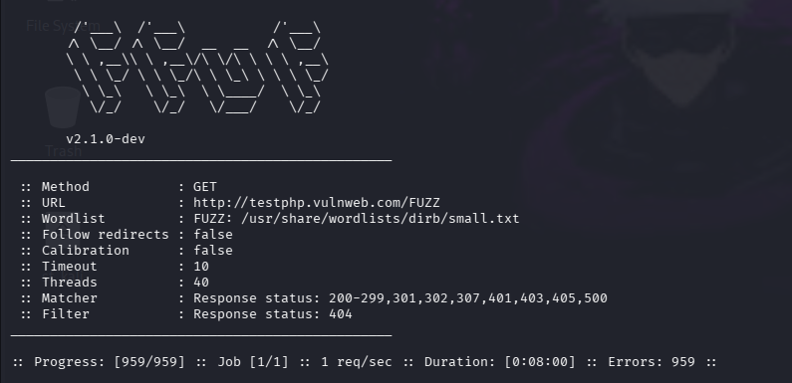
Findings
The scan completed all entries in 8 minutes at 1 req/sec however all 959 requests resulted in errors indicating the target server was actively rate limiting or blocking automated fuzzing requests, suggesting the presence of server-side protection mechanisms against directory brute forcing.

File Extension Fuzzing using ffuf

What it does:
Tests common file extensions to find hidden files like backups and config files
Command:
ffuf -u http://testphp.vulnweb.com/FUZZ -w /home/kali/mywordlist.txt -e .php,.txt,.html -fc 404
Output
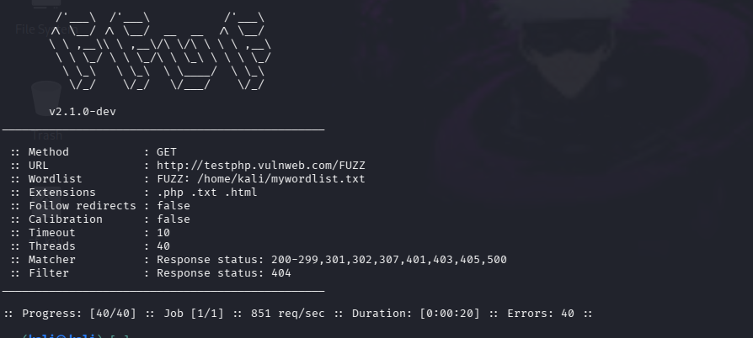

Findings
The scan processed all 40 entries at 851 req/sec in 20 seconds however all requests resulted in errors, further confirming the target server has active protection mechanisms blocking automated fuzzing attempts.
Recursive Directory Fuzzing using ffuf
What it does:
Finds directories then automatically goes inside each one to find nested hidden paths
Command:
ffuf -u http://testphp.vulnweb.com/FUZZ -w /home/kali/mywordlist.txt -recursion -recursion-depth 3 -fc 404 -t 5
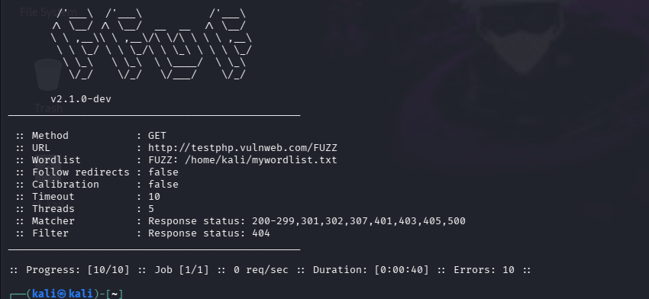
Output

Findings:
The scan processed all 10 entries in 40 seconds however all requests resulted in errors at 0 req/sec, consistently confirming the target server actively blocks and rate limits automated directory fuzzing tools.

GET Parameter Discovery using ffuf
What it does:
Tries thousands of parameter names in the URL to find hidden inputs the website accepts
Command:
ffuf -u "http://testphp.vulnweb.com/listproducts.php?FUZZ=test" -w /home/kali/params.txt -fw 123
Output
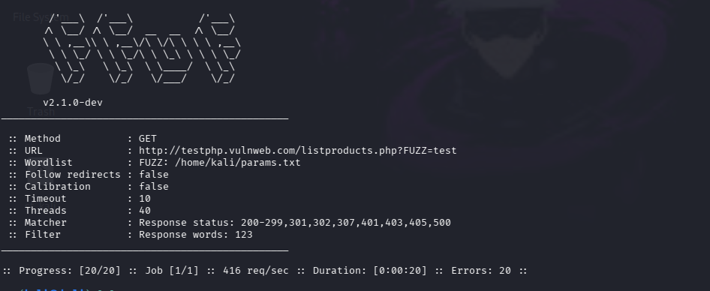
Findngs
The scan processed all entries at 416 req/sec in 20 seconds filtering responses with 123 words. All 20 requests resulted in errors indicating the target was blocking automated parameter discovery attempts on the listproducts.php endpoint.

POST Parameter Discovery using ffuf
What it does:
Tries thousands of hidden form field names in POST requests to find what the server accepts
Command:
ffuf -X POST -u http://testphp.vulnweb.com/login.php -d "FUZZ=admin" -w /home/kali/params.txt -fc 400,404
Output
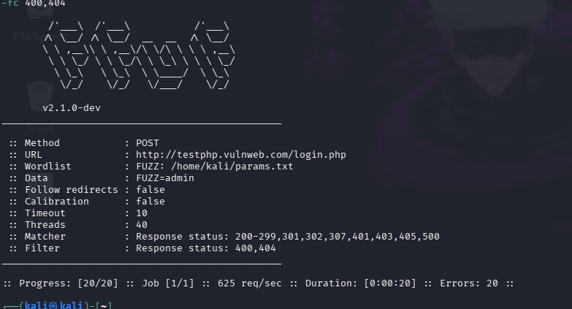

Findings
The scan processed all 20 entries at 416 req/sec in 20 seconds filtering responses with 123 words. All 20 requests resulted in errors indicating the target was blocking automated parameter discovery attempts on the listproducts.php endpoint.

HTTP Header Fuzzing using ffuf
What it does:
Tests thousands of HTTP header names to find ones that change server behaviour
Command
ffuf -H "FUZZ: test" -u http://testphp.vulnweb.com -w /usr/share/seclists/Discovery/Web-Content/burp-parameter-names.txt -fc 400
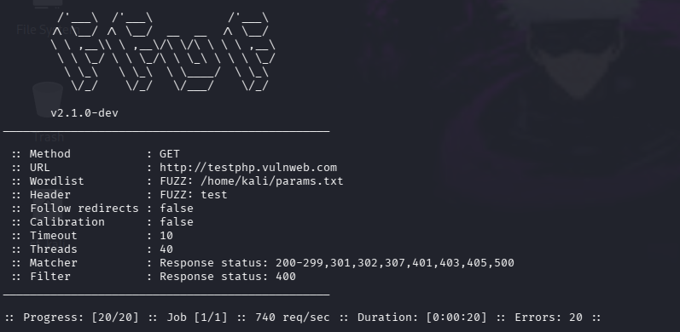
Output
Findings
The scan processed all 20 entries at 740 req/sec in 20 seconds filtering responses with status 400. All 20 requests resulted in errors indicating no sensitive headers were discovered and the server was blocking header fuzzing attempts.

WAF Detection using wafw00f
What it does:
Detects if a website is protected by a Web Application Firewall and identifies which one
Command
wafw00f testphp.vulnweb.com
Output:
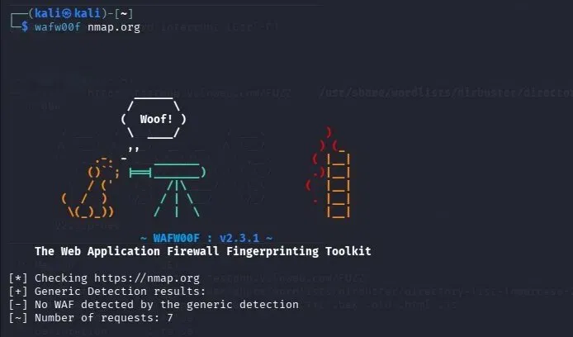

Findings
The scan completed 7 requests and performed generic detection however no WAF was detected on the target. This indicates nmap.org does not have a web application firewall in place, meaning the site is potentially more vulnerable to direct web attacks without WAF-based protection.

Aggressive WAF Detection using wafw00f
What it does:
Uses all detection techniques to thoroughly identify any WAF protecting the target
Command
wafw00f http://testphp.vulnweb.com -a
Output

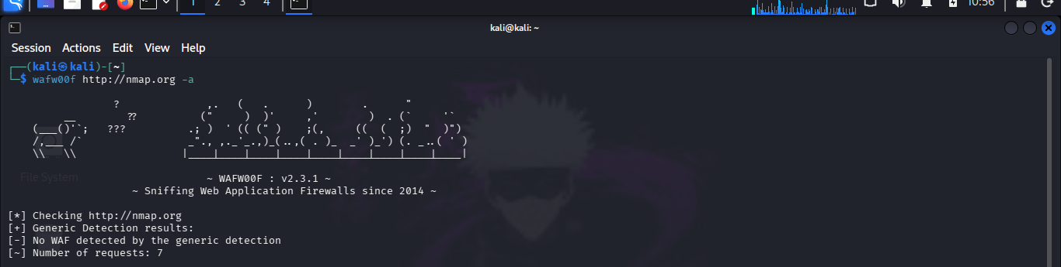

Findings
The scan performed generic detection across multiple requests and confirmed no WAF was detected on the target. This is consistent with the previous HTTPS scan result, confirming that nmap.org operates without any web application firewall protection on both HTTP and HTTPS protocols.

JavaScript File Collection using katana
What it does:
Crawls the website and collects all JavaScript file URLs by executing JS like a real browser
Command
katana -u http://testphp.vulnweb.com -jc -kf all -o js-urls.txt
Output
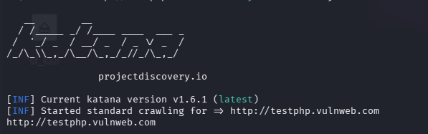
Findings
The crawler initiated standard crawling of the target however only the root URL http://testphp.vulnweb.com was discovered, indicating minimal crawlable content or JavaScript-rendered pages that static crawlers cannot access, suggesting the site relies on limited linking structure.

Historical JavaScript Discovery using gau
What it does:
Fetches all historically archived JS file URLs from public sources without touching the target
Command
gau --subs testphp.vulnweb.com | grep "\.js$" | sort -u
Output
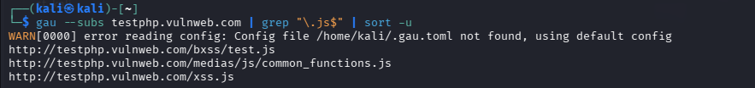

Findings
The tool successfully discovered 3 JavaScript files including http://testphp.vulnweb.com/bxss/test.js, http://testphp.vulnweb.com/medias/js/common_functions.js, and http://testphp.vulnweb.com/xss.js. The presence of xss.js and bxss/test.js are particularly noteworthy as they suggest the target contains cross-site scripting related functionality and testing scripts.

Live JS File Filtering using httpx

What it does:
Checks which collected JS files are actually live and returning a valid response
Command
curl -s https://www.bbc.com | grep -Eo 'src="[^"]*\.js"' | sed 's/src="//;s/"//' > js-urls.txt cat js-urls.txt | /usr/local/bin/httpx -mc 200 | tee live-js.txt
Output
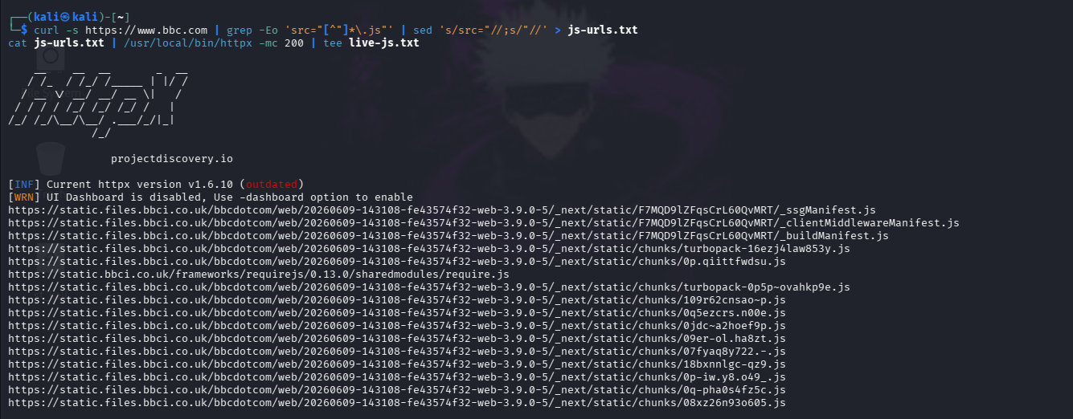
Findings
JavaScript file references were extracted from the BBC homepage HTML and verified for live status returning HTTP 200 responses. Numerous live JS files were discovered hosted on static.files.bbci.co.uk and static.bbci.co.uk including framework files, chunk files, manifest files and middleware files, confirming a large JavaScript attack surface on the target.

Hidden URL Extraction from JavaScript
What it does:
Downloads each live JS file and extracts every hidden URL found inside the code
Command
cat live-js.txt | while read url; do
curl -s "$url" | grep -Eo 'https?://[^"'\''` >,;)]+' | sort -u Done
Output:
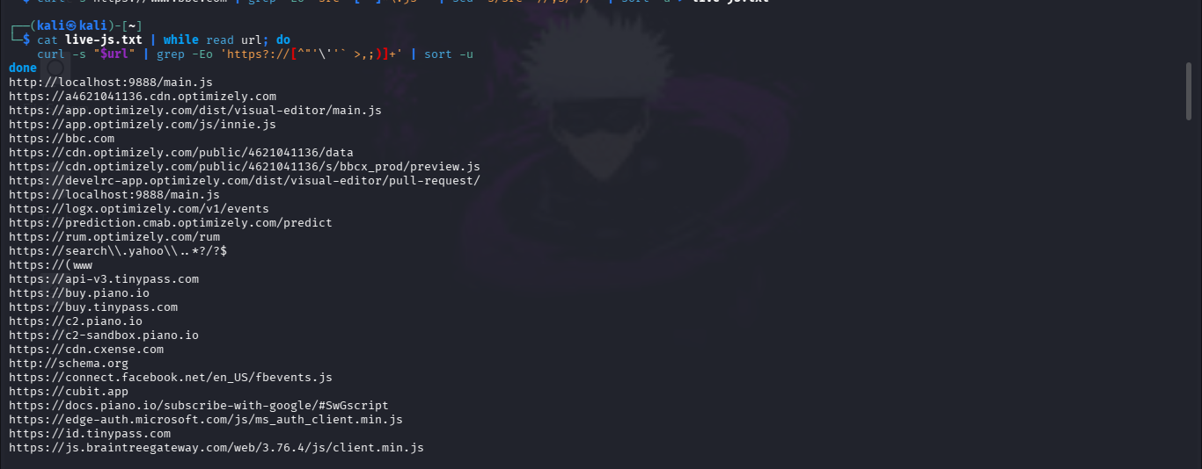

Findings
Hundreds of embedded URLs were extracted revealing third party services and internal endpoints including Optimizely analytics and A/B testing endpoints, Facebook and Microsoft authentication services, payment gateways such as Braintree and Piano.io, advertising and tracking services, and internal BBC APIs. This reconnaissance reveals the full third party dependency chain and potential attack vectors through external service integrations.

API Endpoint Discovery from JavaScript

What it does: Reads through JS files and pulls out only API endpoint paths hidden inside the code

Command
cat live-js.txt | while read url; do
curl -s "$url" | grep -Eo '/api/[^"'\''` >,;)]+' | sort -u
Done
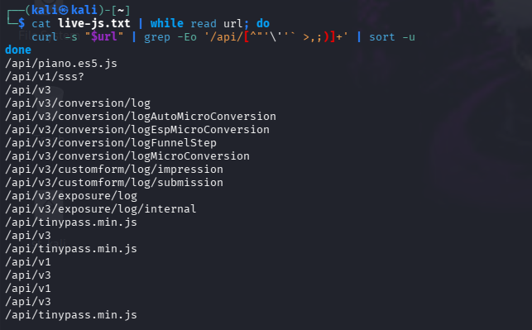
Output

Findings
Multiple API endpoints were successfully discovered including versioned API paths /api/v1 and /api/v3, conversion tracking endpoints such as /api/v3/conversion/log, /api/v3/conversion/logAutoMicroConversion, /api/v3/conversion/logEspMicroConversion and /api/v3/conversion/logFunnelStep, custom form tracking endpoints /api/v3/customform/log/impression and /api/v3/customform/log/submission, and exposure logging endpoints /api/v3/exposure/log and /api/v3/exposure/log/internal. These discovered API endpoints could be used for further testing of authentication, authorization and input validation vulnerabilities.

